Asian American Movement (Yellow Power)
In the late 1960s, large numbers of Asian Americans, particularly college students, began to protest a long history of discrimination. Since the 1850s, racism directed at Asians led to laws limiting Asian immigration to the U.S., prohibiting marriage between whites and Asians, restricting ownership of property, and enforcing school segregation. In addition to these laws, Japanese Americans were placed in internment camps during World War II because they were considered a national threat.
Inspired by the “Black Power” and the civil rights movement, Asian Americans organized in the 1960s to change their status in society. They called for Asian studies programs in colleges, the development of a united Asian-American community, and an end to racism, especially negative stereotyping of Asians in the media.

Key Successes
- Successfully used marches and demonstrations to persuade officials to develop Asian studies programs on college campuses.
- Established numerous programs to serve Asian American communities
- Raised awareness about the need to establish a common Asian-American identity.
- In 1988, President Reagan signed the Civil Liberties Act, providing reparations for surviving victims of Japanese internment camps.
Shortcomings
- Many Asian Americans still continue to face discrimination in American society
- Groups of differing Asian heritage have had difficulty uniting for a common cause.
- Some Asian Americans have had difficulty advancing in society because many Americans view Asian Americans as a single group and a “model minority” – one that has succeeded in spite of enormous obstacles – that does not require assistance or support.

Asian American Alliance

SNCC & the Black Panthers (Black Power)
In 1966, two key civil rights organizations—SNCC and Black Panthers—embraced Black Power. Stokely Carmichael was elected chairman of SNCC and proceeded to transform SNCC from an inter-racial organization committed to nonviolence and integration into an all-black organization that was committed to bringing political and economic power to African Americans. Carmichael called on blacks to form their own separate political organizations, elect black political leaders, supporting black-owned businesses, and use violence against whites if necessary. Carmichael rejected white values of style, adopted the slogan of "Black is Beautiful," and supported the wearing of Afro hairstyles and African forms of dress.
The Black Panther Party for Self-Defense was founded in Oakland, California by activists Huey Newton and Bobby Seale. The two college-educated activists were frustrated with the mainstream civil rights movement’s emphasis on integration and nonviolence. They argued that the movement was ineffective, and that it had failed to relieve the poverty and powerlessness faced by many urban blacks. They founded the organization in response to what the black community perceived as systematic harassment and brutality by the predominately-white Oakland Police Force. Arming themselves for self-defense, the Panthers followed police officers and monitored their actions. The Black Panthers created programs to help cure the social and economic ills afflicting African Americans in Oakland.

Key Successes
- Established a school breakfast program for children in Oakland that served as many as 200 children a day.
- Created adult education classes to increase literacy rates among black adults.
- Started a summer school program for Oakland youth promoting black pride and self-esteem.
- Raised awareness about the issue of police brutality through their neighborhood patrols.
Shortcomings
- The Panthers’ open display of firearms provoked the FBI’s Counter-Intelligence Program to “expose, disrupt, misdirect, discredit or otherwise neutralize” the Black Panthers; the FBI was involved in forging leaflets, posters and correspondence to discredit the group.
- Oakland Police raids on Panther offices resulted in the arrests and shooting deaths of several members.
- Panthers were unable to sustain a following or raise the funds necessary to transform their revolutionary ideas into a larger, more successful political movement.
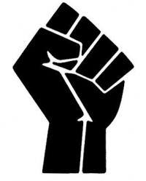

Chicanos, Cesar Chavez, & the United Farm Workers (Brown Power)
In the early 1960s, Cesar Chavez began mobilizing migrant farm laborers, particularly Mexican and Mexican American farm workers, to speak out against decades of exploitation. Chavez was a former migrant worker who established a union called the United Farm Workers (UFW) and organized nonviolent protests against the low wages, unsafe working conditions, and long hours typical in migrant farm labor. He organized boycotts against growers for whom the laborers worked. By 1970, he had successfully won recognition of the UFW by most of the growers in California.
Additionally, a wide array of organizations were created the 1960s and 70s that tried to better the lives of Mexican Americans. These organizations were made up primarily of either youth on college campuses or those living in urban neighborhoods of the American southwest. Mexican-American groups embraced the terms “Chicano” (Mexicano) and “La Raza” (the race) to emphasize pride in their Mexican heritage.

Key Successes
- The two-year boycott of by the UFW resulted in most grape growers in California signing contracts recognizing the UFW union and its right to collectively bargain for its members.
- Unionization led to higher pay and better, safer working conditions for many farm workers.
- The UFW achieved long-lasting prominence as a political organization, gaining support from church groups, other unions and political leaders like Robert Kennedy.
- Chicano youth organizations contributed to growing racial pride and unity in the Mexican-American community

Shortcomings
- The vast majority of farm workers remained unaffiliated and unrepresented.
- Farm worker wages remain low and working conditions poor overall.
- Most farm workers continue to suffer inadequate housing and miserable living conditions.
- Mexican Americans remained underrepresented on college campuses.

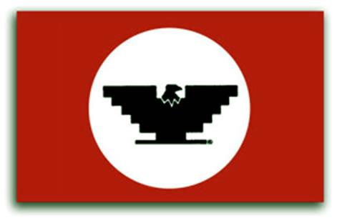
U.F.W.

The Gay Liberation Movement (Rainbow Power)
Before the late 1960s, most homosexuals were quiet about their sexual orientation for fear of losing jobs, friends, and families. In the early 1970s, the gay community became an increasingly vocal force fighting for civil rights and societal acceptance. The gay liberation movement started most notably in 1969 when hundreds of gay men and lesbians in New York City protested decades of police harassment of homosexuals and the arrest of several gay men after a police raid at the Stonewall Inn (a gay nightclub). These “Stonewall riots” led to a major shift in attitudes among gay and lesbian Americans, who began to demand equal rights and societal acceptance.
“Gay Pride” demonstrations and parades were held in major cities, and a newspaper, The Advocate, promoted gay rights issues. Millions of gays and lesbians “came out of the closet” and openly declared their sexual preference. The Gay Liberation Front (GLF) worked to convince Americans that homosexuals are not dangerous sexual deviants but rather people who deserved equal rights and recognition.

Key Successes
- Raised awareness of violence against homosexuals, ended police raids on gay bars, and helped American society become more open and accepting of homosexuality, as demonstrated by the number of gay and lesbian characters in television and film.
- In 1977, the gay community made a breakthrough when Harvey Milk, an openly gay man, was elected to the Board of Supervisors in San Francisco, California. Since the late 1970s, numerous openly gay politicians have been elected.
- In 1998, 313 companies, including Disney and IBM, extended health and retirement benefits to “domestic partners” of gay and lesbian employees.
- Gay rights advocates have successfully lobbied for funding for AIDS research.
- In 2015, the Supreme Court, citing the 14th Amendment to the Constitution, declared same-sex marriage legal nation-wide.

Shortcomings
- The Non-Discrimination Act, a law outlawing discrimination in the workplace based on sexual preference, has failed to pass in Congress ten times, most recently in 2013.
- Laws regarding gay and lesbian adoptions remain restrictive.

The Native American Movement (Red Power)
Inspired by the African American civil rights movement, Native Americans organized the “Red Power” movement to seek their own civil rights. By the 1960s, American Indians had the lowest income, worst health, highest suicide rate, shortest life expectancy and highest unemployment rate of any minority group in the United States. Native American activists tried to draw attention to these conditions by suing the federal government and organizing protest marches to demand Indian autonomy and the return of Indian lands lost because of broken treaties. In 1969, 78 Indians occupied Alcatraz Island in San Francisco Bay; in 1972 the militant American Indian Movement (AIM) occupied the Bureau of Indian Affairs in Washington, DC; and in 1973, 200 armed AIM members took control of Wounded Knee in South Dakota, the site of the 1890 massacre of Indians. In each of these protests, American Indians brought attention to their cause.

Key Successes
- Congress approved $510 million for Indian aid programs in 1968.
- Through legal battles, Native Americans won back 7 million acres of former Indians lands in South Dakota and 1,800 acres in Rhode Island.
- Indians have been appointed to top positions at the Bureau of Indian Affairs.
- Congress passes the Indian Self-Determination and Education Act in 1975, giving Indians more say in their reservations and their education. Federal support was obtained for curriculum in Indian schools that stresses tribal history and heritage.

Shortcomings
- Most Native Americans continue to live in poor conditions on Indian reservations.
- Alcoholism, suicide, poor health and sanitary conditions and high unemployment continue to plague the Native-American population.
- The armed occupations at Alcatraz, Washington DC, and Wounded Knee were unsuccessful in obtaining land and ended in property damage, the deaths of two Indians, numerous arrests, and divisiveness within the Native-American community.

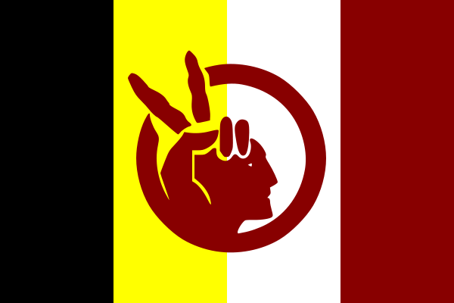

The Women’s Movement (Pink Power)
In 1966, Betty Friedan published The Feminine Mystique, which argued that the American home had become a “comfortable concentration camp” for women who were pressured by society to be “happily content in a world of bedroom, kitchen, sex, babies, and home.” The book launched the women’s movement in America. Betty Freidan co-founded the National Organization for Women (NOW), which became an important venue for bringing attention to women’s issues. Feminists drew attention to the lack of rights for women and demanded improved education, job opportunities, healthcare, childcare facilities, legal and safe abortion, and shared parenting (greater emphasis on fathers’ roles in bringing up children). In the 1960s and 1970s, feminists called for the passage of an Equal Rights Amendment (ERA) to the Constitution, which would ban discrimination on the basis of sex. Friedan and Gloria Steinem (editor of the feminist-themed Ms. magazine) actively campaigned for the ERA.

Key Successes
- Succeeded in raising awareness of women’s unequal status in American society.
- Congress passed Title VII to protect women against sexual harassment and discrimination because of pregnancy or disability
- Congress passed Title IX to protect women’s athletic programs and to outlaw discrimination in educational programs that received federal money.
- The Supreme Court ruled in the 1973 Roe v Wade case that states could not make it illegal for women to have an abortion in the early stages of pregnancy.

Shortcomings
- The ERA was never passed. Though approved by Congress in 1972 and ratified by 22 states, the ERA died 3 states short of passage in 1982.
- Women continue to face discrimination and sexual harassment in many areas of employment and are still not paid the same as men for equal work.
- Government sponsored childcare was never established.

The Environmental Movement (Green Power)
In 1962, biologist Rachel Carson published the book Silent Spring that exposed the dangers of using pesticides, specifically DDT, on the environment and the ecosystem. She had become concerned during the 1950s at the rapid increase in pesticides by farmers and government agencies. Reaction to her book led the government to organize an investigation of the industry and sparked the environmental movement. In 1970, the government created the Environmental Protection Agency (EPA) The United States also passed new legislation such as the Clean Water Act, the Clean Air Act, the Endangered Species Act, and the National Environmental Policy Act- the foundations for current environmental standards.

Key Successes
- The public has become more aware of environmental issues, such as air, water, and noise pollution, solid waste disposal, dwindling energy resources, radiation, pesticide poisoning.
- Americans celebrate Earth Day each year on April 22 to bring awareness to environmental concerns and emphasize the slogan: “think globally, act locally.”
- New technologies such as bio-fuels and alternative energies are being invented to combat environmental and energy shortages.

Shortcomings
- The United States remain the most oil dependent country in the world.
- Numerous issues continue to threaten the global environment, such as global warming, depleted natural resources such as oil, air and water pollution (especially among developing nations), growing numbers of endangered or extinct plants and animals.

