Name: _____________________________________________ Date: ___________
The Boston Massacre Primary Sources
Read document #1 and #2. Highlight words that you think are important, stand out, are repeated, etc. Determine the importance/main idea of each document.
Document #1
On Monday night about 8 o'clock two soldiers were attacked and beat.
About 9 (o’clock) some of the guard came to and informed me the town inhabitants were assembling to attack the troops.
In a few minutes about 100 people went towards the custom house where the king's money is lodged. They immediately surrounded the sentry (guard) posted there, and with clubs and other weapons threatened to execute their vengeance on him.
I was soon informed by a townsman their intention was to carry off the soldier from his post and probably murder him. On which I desired him to return for further intelligence (information), and he soon came back and assured me he heard the mob declare they would murder him.
This I feared might be a prelude (beginning) to their plundering (robbing) the king's chest. I immediately sent a non-commissioned officer and 12 men to protect both the sentry and the king's money, and very soon followed myself to prevent, if possible, all disorder, fearing lest the officer and soldiers, by the insults and provocations of the rioters, should be thrown off their guard and commit some rash act.
My intention was not to act offensively, but the contrary part, and that not without compulsion (obsession). The mob still increased and were more outrageous, striking their clubs one against another, and calling out, come on you rascals, you bloody backs, you lobster scoundrels, fire if you dare, G-d damn you, fire and be damned, we know you dare not, and much more such language was used. .
While I was thus speaking, one of the soldiers having received a severe blow with a stick, stepped a little on one side and instantly fired, on which turning to and asking him why he fired without orders, I was struck with a club on my arm, which for some time deprived me of the use of it, which blow had it been placed on my head, most probably would have destroyed me.
On this a general attack was made on the men by a great number of heavy clubs and snowballs being thrown at them, by which all our lives were in imminent (immediate) danger, some persons at the same time from behind calling out, damn your bloods-why don't you fire.
Instantly three or four of the soldiers fired, one after another, and directly after three more in the same confusion and hurry. The mob then ran away, except three unhappy men who instantly expired (died), one more is since dead, three others are dangerously, and four slightly wounded.
Immediately after a townsman came and told me that 4 or 5000 people were assembled in the next street, and had sworn to take my life with every man's with me. On which I judged it unsafe to remain there any longer, and therefore sent the party and sentry to the main guard.
Captain Thomas Preston 29th Regiment of Foot Describing the events of March 5, 1770
Document #2
A few minutes after nine o'clock four youths, named Edward Archbald, William Merchant, Francis Archbald, and John Leech, came down Cornhill together, the two former were passing the narrow alley leading Mr. Murray's barrack in which was a soldier brandishing (holding) a broad sword of an uncommon size against the walls, out of which he struck fire plentifully. A person of mean countenance (appearance) armed with a large cudgel (club) bore him company.
Edward Archbald admonished (told) Mr. Merchant to take care of the sword, on which the soldier turned round and struck Archbald on the arm, then pushed at Merchant and pierced through his clothes inside the arm close to the armpit and grazed the skin. Merchant then struck the soldier with a short stick he had; and the other person ran to the barrack and brought with him two soldiers, one armed with a pair of tongs (restraining device), and the other with a shovel.
He with the tongs pursued Archbald back through the alley, collared and laid him over the head with the tongs. The noise brought people together; and John Hicks, a young lad (boy), coming up, knocked the soldier down but let him get up again; and more lads gathering, drove them back to the barrack where the boys stood some time as it were to keep them in. In less than a minute ten or twelve of them came out with drawn cutlasses (swords), clubs, and bayonets and set upon the unarmed boys and young folk who stood them a little while but, finding the inequality of their equipment, dispersed (left).
Thirty or forty persons, mostly lads, being by this means gathered in King Street, Capt. Preston with a party of men with charged bayonets, came from the main guard to the commissioner's house, the soldiers pushing their bayonets, crying, make way! They took place by the custom house and, continuing to push to drive the people off pricked some in several places, on which they were clamorous (noisy) and, it is said, threw snow balls.
On this, the Captain commanded them to fire; and more snow balls coming, he again said, damn you, fire, be the consequence what it will! One soldier then fired, and a townsman with a cudgel (club) struck him over the hands with such force that he dropped his firelock (musket); and, rushing forward, aimed a blow at the Captain's head which grazed his hat and fell pretty heavy upon his arm. However, the soldiers continued the fire successively till seven or eight or, as some say, eleven guns were discharged.
By this fatal maneuver (action) three men were laid dead on the spot and two more struggling for life; but what showed a degree of cruelty unknown to British troops, at least since the house of Hanover has directed their operation, was an attempt to fire upon or push with their bayonets the persons who undertook to remove the slain and wounded!
Source: The Boston Gazette and Country Journal, March 12, 1770

Document #3
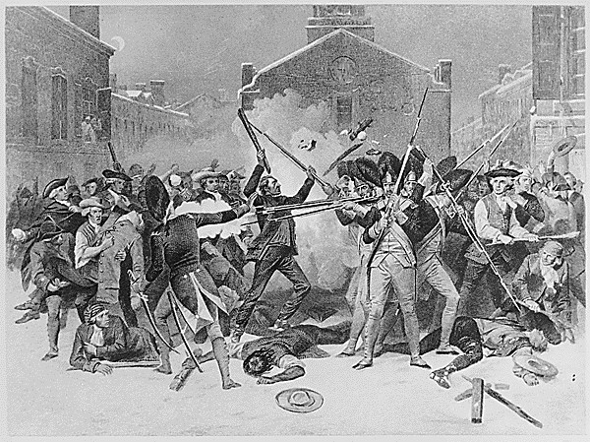
Chappel, Alonzo. Boston Massacre. Painting.1865.
Document #4
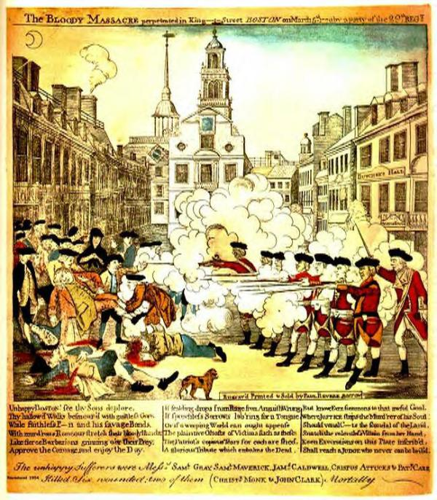
Revere, Paul. The Bloody Massacre Perpetrated in King Street Boston on March 5th 1770, by a Party of the 29th Regt. Hand colored engraving, 1770.

Text Based Questions:
- What is the importance or main idea of Document #1 Captain Thomas Preston’s account? (Cite specific examples/words/phrases).
________________________________________________________________________________________________________________________________________________________________________________________________________________________
- What is the importance or main idea of Document #2 The Boston Gazette article? (Cite specific examples/words/phrases).
________________________________________________________________________________________________________________________________________________________________________________________________________________________
- Which document do you think represents Document #3, Alonzo Chappel’s painting, and why?
________________________________________________________________________________________________________________________________________________________________________________________________________________________________________________________________________________________________________________________________________________________________________________________________________________________________________________

- Which document do you think represents Document # 4 Paul Revere’s engraving and why?
________________________________________________________________________________________________________________________________________________________________________________________________________________________________________________________________________________________________________________________________________________________________________________________________________________________________________________

