On Victory in Europe
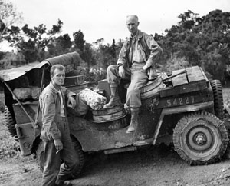
IU Archives
Pyle with an Army Jeep driver.
And so it is over. The catastrophe on one side of the world has run its course. The day that it had so long seemed would never come has come at last. I suppose our emotions here in the Pacific are the same as they were among Allies all over the world. First a shouting of the good news with such joyous surprise that you would think the shouter himself had brought it about.
And then an unspoken sense of gigantic relief-and then a hope that the collapse in Europe would hasten the end in the Pacific.
It has been seven months since I heard my last shot in the European War. Now I am as far away from it as it is possible to get on this globe.
This is written on a little ship lying off the coast of the Island of Okinawa, just south of Japan, on the other side of the world from Ardennes.
But my heart is still in Europe, and that’s why I am writing this column.
It is to the boys who were my friends for so long. My one regret of the war is that I was not with them when it ended.
For the companionship of two and a half years of death and misery is a spouse that tolerates no divorce. Such companionship finally becomes a part of one’s soul, and it cannot be obliterated.
True, I am with American boys in the other war not yet ended, but I am old-fashioned and my sentiment runs to old things.
To me the European War is old, and the Pacific War is new.
Last summer I wrote that I hoped the end of the war could be a gigantic relief, but not an elation. In the joyousness of high spirits it is so easy for us to forget the dead. Those who are gone would not wish themselves to be a millstone of gloom around our necks.
But there are so many of the living who have had burned into their brains forever the unnatural sight of cold dead men scattered over the hillsides and in the ditches along the high rows of hedge throughout the world.
Dead men by mass production-in one country after another-month after month and year after year. Dead men in winter and dead men in summer.
Dead men in such familiar promiscuity that they become monotonous.
Dead men in such monstrous infinity that you come almost to hate them.
Those are the things that you at home need not even try to understand. To you at home they are columns of figures, or he is a near one who went way and just didn’t come back. You didn’t see him lying so grotesque and pasty beside the gravel road in France.
We saw him, saw him by the multiple thousands. That’s the difference.
We hope above all things that Japan won’t make the same stubborn mistake that Germany did. You must credit Germany for her courage in adversity, but you can doubt her good common sense in fighting blindly on long after there was any doubt whatever about the outcome.

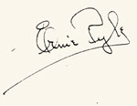
Source: From handwritten Pyle original, which belongs to Albuquerque Public Library, but in October 2013, it was on loan to Santa Fe. Also published on the front page of the Pittsburgh Press, Sept. 24, 1945.

